**What is a Blockchain ?**

A Blockchain is a large, decentralized database that collects all transactions in blocks.

In each block there is a certain number of transactions. When the block is full, further transactions are written to the next block.

This creates a chain and a forgery-proof, unchangeable and transparent transaction history.

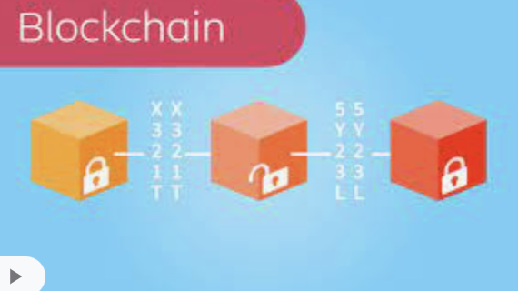

**Characteristics**

The features of the blockchain are:

#1 Storage of every transaction

#2 Decentralized with many participants

#3 Management of the entire transaction history

**2 essential application examples**

What can blockchain technology be used for?

**2 examples:**

1. Cryptocurrencies: Cryptocurrencies are the best-known use case for blockchain technology
2. Smart contracts*: Smart contracts (“intelligent contracts”) are contracts based on blockchain technology and do not require a third party (e.g. a notary) to ensure legal certainty. In addition, smart contracts can come into force automatically under certain conditions.

**What are the pros of the blockchain ?**

* Security: Once the information is attached to the “blockchain” and verified, it cannot be changed
* **Transparency:** Each transaction is stored encrypted, but is visible to everyone.
* **Cost savings:** The data on the blockchain can be relied on without trusting the other party. This eliminates the need for third parties who are normally involved as a control body, such as a bank or, in the future, a notary. This lowers costs.
* **Time saving:** The technology works 100% digitally like a central and digital bookkeeping, which reduces the communication effort and minimizes the potential for errors through automation. This leads to a time saving.
* **Many use cases:** Smart Contracts can be a significant simplification for companies, authorities and consumers, as they offer many areas of application such as insurance, real estate, cars, rent.

**What are the cons of the blockchain ?**

* **High storage requirements:** The blockchain grows with each block, the amount of data in the blockchain increases. This requires a lot of storage space
* **Complex implementations and new technologies**: poses challenges for IT departments. More specialists are needed with blockchain know-how
* **Currently still harmful to the environment:** In order to be able to mine the blocks of the blockchain technology on which the cryptocurrencies are based, a lot of computing power is required - and that eats up a lot of electricity. But not only mining itself is energy-intensive, every single transaction with an internet currency also consumes a lot of energy. Here, however, work is already being done on environmentally friendly solutions.

*see separate video “What are Smart Contracts”